**LAB 1**

Q4: Find the sum of digits of a given integer number.

**Algorithm –**

1. Start
2. Store the integer in a variable namely ‘a’. Initialize sum = 0;
3. Repeat steps 4 and 5 until the number (a) is not 0.
4. Sum = Sum + a % 10.
5. a = a / 10.
6. Print Sum.
7. End

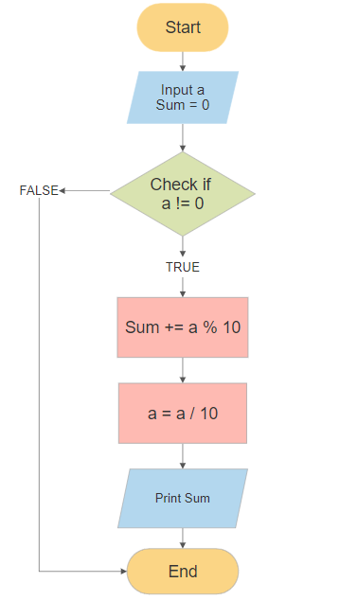

**SPARSH CHADHA**

**E18CSE179**